Basic Study Questions

For

Grade 1

Please note: the first number before each question indicates in which chapter of the textbook the topic of the question can be found.

7/2025

Grade 1 First Semester (Chapters 1-16)

1.1 Why do we call God Father?
God is called Father because He is the One who created us.
He created us in His image. He created us either male or female.

1.2 What is prayer?
Prayer is talking with and listening to God.

2.1 What is Heaven?
Heaven is God’s home and a place of perfect happiness with God.

3.1 Where is God?
God is in Heaven, on earth and everywhere.

3.2 What does it mean to create?
To create means to make something out of nothing.

3.3. What are angels?
Angels are invisible spirits. They praise God and are God’s helpers.

3.4 What do we call the angels who turned away from God?
We call the angels who turned away from God, devils.

4.1 What makes you a human being?
I am a human being because I have a body and a soul.

4.2 What is the soul?
The soul is an invisible gift from God that gives us life and lives forever.

4.3 Will your soul ever die?
No, my body will die, but my soul will live forever.

4.4 What is a guardian angel?
A guardian angel is an angel given to each person by God. This angel protects us and helps us to be good.

5.1 Who were the first man and woman?
Adam was the first man and Eve was the first woman.

5.2 What is grace?
Grace is the gift of God’s life in our soul.
We receive special grace through the sacraments.

5.3 How do we keep God’s grace in us?
We keep God’s grace in us by following His laws.

6.1 What is sin?
Sin is choosing to do something we know is wrong; it is disobeying God.

6.2 What is Original Sin?
Original Sin is the sin of Adam and Eve. We are all born with this sin on our soul.

6.3 How do we get rid of Original Sin and make our soul clean?
Our soul is washed clean of Original Sin through Baptism.

6.4 After Adam and Eve sinned, what did God promise?
After Adam and Eve sinned, God promised to send a Savior.

7.1 Did the savior come right away?
No, the savior did not come for many years.

7.2 Name two men who loved and served God well as they waited for the Savior.
Noah and Abraham were two men who loved and served God well as they
waited for the Savior.

7.3 What is faith?
Faith is a gift from God which makes us able to believe in Him and His teachings.

8.1 What are prophets?
Prophets were holy men who prepared people for the coming of the Savior, Jesus Christ.

8.2 Who was the first prophet?
Moses was the first prophet.

8.3 What did God give to Moses to share with the people?
God gave Moses the Ten Commandments to share with the people.

8.4 What are the Ten Commandments?
The Ten Commandments are God’s Laws for all people of all time.

8.5 Who was the last prophet of the Old Testament?
Saint John the Baptist was the last prophet of the Old Testament.

9.1 Who is Mary?
Mary is the Mother of Jesus, the Savior.

9.2 What very special gift did God give to Mary (our Blessed Mother) before she was
born?
God’s made Mary free from Original Sin from the very first moment of her life.

9.3 Who is St. Joseph?
St. Joseph is Jesus’ father on earth (foster-father).

10.1 Name the members of the Holy Family.
The Holy Family is Jesus, Mary and Joseph.

10.2 Where was Jesus born?
Jesus was born in Bethlehem, in a stable, and placed in a manger.

10.3 Who is Jesus Christ?
Jesus Christ is the Second Person of the Blessed Trinity; he is the Son of God made man.

10.4 Why did the Son of God become man?
The Son of God became man to save us from sin and to open the gates of Heaven for us.

10.5 What is Christmas?
Christmas is the birthday of Jesus.

10.6 What does it mean to worship?
To worship means to give your best love and praise to God. Only God should be worshipped.

13.1 Who are the Apostles?
The Apostles were friends of Jesus who learned from Him and were sent by Him to share with others what they learned. They became the first bishops.

14.1 What was the Good News that Jesus told the people?
Jesus told the people that God loves all of them.

14.2 What is the Great Commandment taught by Jesus?
a. Love God with all your heart, soul, mind and strength.
b. Love your neighbor as yourself.

14.3 What is the Bible?
The Bible is the holy book which tells us about God’s special people, about
Jesus and about the beginning of the Church.

15.1 What is a miracle?
A miracle is something wonderful which can only be done by the power of God.

15.2 Why did Jesus perform miracles?
Jesus performed miracles to show that He is truly the Son of God.

16.1 What is the reward for faith?
The reward for faith is making God happy and going to Heaven.

*******************************************************************

- Grade 1 Second Semester (Chapters 17-28 including We Go to Mass supplement)

17.1 What happened on Holy Thursday?
On Holy Thursday, Jesus and His Apostles shared the Last Supper, which was the first Mass.

17.2 At the Last Supper, what did Jesus do with the bread and wine?
At the Last Supper, Jesus changed the bread and wine into His Body and Blood.

17.3 Why can priests today change the bread and wine into the Body and Blood of Jesus?
Jesus gave this power to His Apostles at the Last Supper and when a man becomes a priest, he receives the same power from Jesus through the Sacrament of Holy Orders.

17.4 Why is Holy Communion a special gift from God?
Holy Communion is a special gift from God because, in Holy Communion, Jesus Himself comes to live in us.

18.1 What happened on Good Friday?
On Good Friday, Jesus died on the Cross.

18.2 Why did Jesus suffer and die on the Cross?
Jesus suffered and died on the Cross because He loves us and wanted to make up for the sins of man. He wanted to open the gates of Heaven for us.

19.1 What happened on Easter Sunday?
On Easter Sunday, Jesus rose from the dead. This is called the Resurrection.

20.1 Who founded/started the Catholic Church?
Jesus Christ started the Catholic Church.

20.2 Why did Jesus start the Church?
Jesus started the Church so the work He started on earth would continue after He went to Heaven. He started the Church to save souls.

20.3 What is the Church?
The Church is the group of baptized people who profess the Catholic Faith
and come together to worship God.

20.4 What are bishops and priests?
Bishops and priests are men who have received the Sacrament of Holy Orders. They teach us about God and how to be holy. They celebrate Mass and bring the Sacraments to us.

20.5 What is a pope?
A pope is a man who has received the Sacrament of Holy Orders and is head of the entire Church on earth. He is the successor of St. Peter. We call the pope Holy Father.

20.6 Who was the first pope?
St. Peter was the first pope.

21.1 What is the Ascension?
The Ascension is the return of Jesus to Heaven forty days after Easter.

22.1 What happened on Pentecost?
On Pentecost, the Holy Spirit came to Mary and the Apostles.

22.2 What did the Holy Spirit do for the Apostles?
The Holy Spirit gave grace to the Apostles and the courage to continue Jesus’
work on earth.

23.1 How many gods are there?
There is ONE God.

23.2 How many Divine persons are there in the one God?
There are three Divine persons in one God.

23.3 What do we call the Three Persons in one God?
We call the Three Persons in one God the Blessed Trinity.

23.4 Who is the First Person of the Blessed Trinity?
God the Father is the First Person of the Blessed Trinity.

23.5 Who is the Second Person of the Blessed Trinity?
God the Son (Jesus) is the Second Person of the Blessed Trinity.

23.6 Who is the Third Person of the Blessed Trinity?
God the Holy Spirit is the Third Person of the Blessed Trinity.

23.7 Has God always existed?
Yes, God has always been and always will be. (think of the Glory Be prayer)

23.8 What is a mystery?
A mystery is something we believe because God has told us it is true, but we do not fully understand it.

24.1 What is a sacrament?
A sacrament is an outward sign instituted (begun) by Jesus Christ to give us
grace.

24.2 What does the Sacrament of Baptism do for you?
Baptism takes away Original Sin. Baptism makes us followers of Christ, children of God, and members of His Church.

25.1 What is the Gospel?
The Gospel is the part of the Bible which tells us what Jesus did and what He said while He was on earth.

25.2 Who wrote the four Gospels?
Matthew, Mark, Luke and John were the four Gospel writers.

25.3 What happens during Mass?
Through the miracle of the Mass, we are present at the Last Supper and Jesus’ sacrifice and death on the Cross. At the Mass, we hear God’s Word from the Bible and most importantly, Jesus gives Himself to us in the Holy Eucharist.

25.4 Why does Jesus give Himself to us in the Holy Eucharist?
Jesus gives Himself to us in the Holy Eucharist to be the life and food of our souls.

S.1* Why is Sunday called the “Lord’s Day”?
Sunday is called the Lord’s Day because Jesus rose from the dead on a Sunday.

S.2* How do we keep the Lord’s Day holy?
We keep the Lord’s Day holy by going to Mass to worship God. We should not
do unnecessary work on the Lord’s Day.

S.3* How do we genuflect?
When we genuflect, we kneel down on our right knee.

S.4* What is the Creed?
The Creed is a statement of what we believe about God and His Church.

26.1 What is a sacrifice?
A sacrifice is giving up something that we like to show God how much we love Him.

27.1 Why should we follow/imitate what Jesus did?
We should follow what Jesus did because by following Him, we can find our way to Heaven.

27.2 What is a saint?
A saint is a holy person who loved God very much on earth, has died and is in Heaven.

28.1 Why did God make you?
God made you to know, love, and serve Him in this world, and to be happy with Him forever in Heaven.

S* - We Go to Mass supplement pp.113-116 of textbook

Prayers and Lists

- The Sign of the Cross
In the name of the Father, and of the Son, and of the Holy Spirit. Amen.

- Glory Be
Glory be to the Father, and to the Son, and to the Holy Spirit, as it was in the beginning is now and ever shall be world without end. Amen.

- Hail Mary
Hail Mary, full of grace the Lord is with thee. Blessed art thou among women, and blessed is the fruit of thy womb, Jesus. Holy Mary, Mother of God, pray for us sinners, now and at the hour of our death. Amen.

4. The Lord’s Prayer (Our Father)
Our Father, Who art in Heaven, hallowed be Thy name; Thy kingdom come; Thy will be done on earth as it is in Heaven. Give us this day our daily bread; and forgive us our trespasses as we forgive those who trespass against us; and lead us not into temptation, but deliver us from evil. Amen.

5. The Guardian Angel Prayer
Angel of God, my guardian dear, to whom God’s love commits me here. Ever this
day be at my side to light and guard, to rule and guide. Amen.

6. Grace before Meals
Bless us, O Lord, and these thy gifts, which we are about to receive, from thy bounty through Christ our Lord. Amen.

7. Name the Twelve Apostles chosen by Christ.

Simon Peter, Andrew, James the Greater, John, Thomas, James the Lesser, Philip, Bartholomew, Matthew, Simon, Thaddeus and Judas

(continued on next page)

7. The Liturgical Year and the colors which go with each Season:
Advent – purple
Christmas (gold and/or white)
Ordinary Time (green)
Lent (purple)
Easter (gold and/or white)

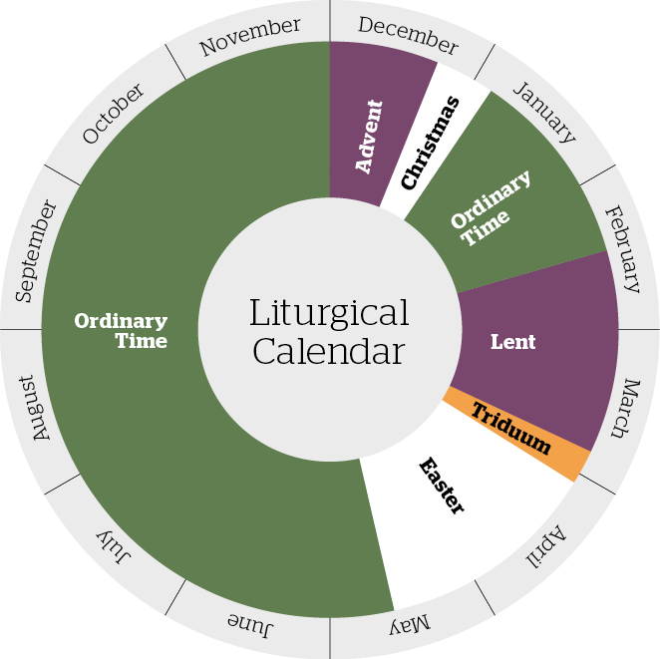

For FUN only:
Please see next page for lists of the Books of the Old Testament and New Testament

Please note: Go to the Parish website (http://straymonds.org/) and under the Formation drop down menu, click on Religious Education – there you will find a link to The Catholic Books of the Bible Song video – a catchy tune by which the children can learn these names.
The Books of the Old Testament
THE PENTATEUCH | BIBLICAL NOVELLAS | PROPHETIC BOOKS
Genesis | Tobit | Isaiah
Exodus | Judith | Jeremiah
Leviticus | Esther | Lamentations
Numbers | 1 Maccabees | Baruch
Deuteronomy | 2 Maccabees | Ezekiel
HISTORICAL | WISDOM BOOKS | Daniel
INTRODUCTION | Job | Hosea
Joshua | Psalms | Joel
Judges | Proverbs | Amos
Ruth | Ecclesiastes | Obadiah
1 Samuel | Song of Solomon | Jonah
2 Samuel | Wisdom | Micah
1 Kings | Sirach | Nahum
2 Kings |  | Habakkuk
1 Chronicles |  | Zephaniah
2 Chronicles |  | Haggai
Ezra |  | Zechariah
Nehemiah

The Books of the New Testament

THE GOSPELS | LETTERS | CATHOLIC LETTERS
Matthew | Romans | James
Mark | 1 Corinthians | 1 Peter
Luke | 2 Corinthians | 2 Peter
John | Galatians | 1 John
Acts of the Apostles | Ephesians | 2 John
 | Philippians | 3 John
 | Colossians | Jude
 | 1Tthessalonians | Revelation
 | 2 Thessalonians
 | 1 Timothy
 | 2 Timothy
 | Titus
 | Philemon
 | Hebrews
Source: USCCB website 7/2025

