Basic Study Questions

For

Grade 5

Please note: the first number before each question indicates in which
chapter of the textbook the topic of the question can be found.

7/2025

- Grade 5 First Semester (Chapters 1-16)

1.1 What is faith?
Faith is a gift from God which enables us to believe in Him and all He
teaches.

1.2 What is revelation?
Revelation is the truths of faith which God has made known to us through Sacred Scripture and Sacred Tradition. [Revelation = to reveal]

1.3 What is a mystery?
A mystery is a truth revealed by God that our human minds cannot fully
understand.

1.4 What is the Apostles’ Creed?
The Creed is a statement of what we believe about God and His Church.
(credo: I believe)

2.1 Who is God?
God is the all-perfect pure spirit. He is eternal (has always existed and always will exist). He is all knowing, almighty, and unchanging.

2.2 How many gods are there?
There is one God.

2.3 How many Persons are there in one God?
There are three Divine Persons in one God.

2.4 What do we call the Three Divine Persons in one God?
We call the Three Persons in one God the Blessed Trinity or the Holy Trinity. The Three Persons are equal and separate. Each Person is God.

2.5 Name the Three Divine Persons of the Blessed Trinity.
The First Person of the Blessed Trinity is God the Father.
The Second Person of the Blessed Trinity is God the Son.
The Third Person of the Blessed Trinity is God the Holy Spirit.

3.1 What does it mean to create?
To create means to make something out of nothing.

4.1 What are angels?
Angels are pure spirits; intelligent beings without bodies. They glorify God and
serve God, sometimes as His messengers.

4.2 What is a guardian angel?
A guardian angel is our own personal angel given to us by God. Our guardian angel protects us (body and soul) and inspires us to do what is good.

5.1 What is man?
Man is a being created by God with a physical body and a spiritual soul. Man is created in God’s image and likeness and is created as either male or female.

5.2 What is a soul?
A soul is the spiritual part of man; it lives forever. The soul allows man to know,
love and serve God.

5.3 What is free will? Does man have free will?
Free will is the ability to choose. Yes, man has free will.

5.4 What are the names of the first man and woman created by God?
Adam was the first man and Eve was the first woman created by God.

5.5 What is sanctifying grace?
Sanctifying grace is the gift of God’s life in our soul. It helps us to become holy and get to Heaven.

6.1 What do we call the sin of Adam and Eve?
We call the sin of Adam and Eve Original Sin, because it was the first sin
committed by man. It is passed on to all people.

6.2 What effect does Original Sin have on all mankind?
Because of Original Sin, we may have difficulty deciding what is right and wrong,
good and bad. Original Sin made mankind spiritually weak and subject to temptation.

6.3 How is Original Sin taken away?
Original Sin is taken away by the Sacrament of Baptism which makes our soul
rich in the grace of God.

7.1 What is a sacrifice?
A sacrifice is offering something up to God that is important to us, in order to
show Him how much we love Him.

7.2 Why is Abraham called our “father in faith”?
Abraham is called our “father in faith” because through his faith and obedience to God, in severe trial, God’s covenant was established with him. Also, Abraham is called our father in faith because from his descendants came the Savior, Jesus.

8.1 Why did God send ten plagues into Egypt?
God sent plagues into Egypt because the Pharaoh refused to release God’s people (the Israelites) from slavery. He also wanted to show the Egyptians that He (Yahweh) is the one true God.

8.2 What is the Passover?
The Passover is a Jewish feast celebrated every year in remembrance of God rescuing His people from slavery in Egypt. It is called Passover because the Angel of Death “passed over” the houses of the people of Israel, whose doors were marked with the blood of a lamb, while He struck down the firstborn of the
Egyptian families.

8.3 How did God free the Israelites from slavery in Egypt?
God freed the Israelites from slavery in Egypt by using Moses to part the Red Sea allowing the Israelites to pass through safely to the land on the other side. When the Egyptian army followed and tried to recapture them, God caused the Red Sea to come back together which drowned the Egyptian army.

9.1 What is manna?
Manna is a flaky bread-like food which God provided to the Israelites as they traveled through the desert for forty years. It prefigures/points to the Holy Eucharist.

9.2 What is a covenant?
A covenant is a deep promise or agreement between two or more persons or groups that establishes family bonds. God made a covenant with His Chosen People, the Israelites.

9.3 What are the Ten Commandments?
The Ten Commandments are the moral laws given to Moses by God for His chosen people. These laws are for all God’s people until the end of time.

10.1 Who were the prophets?
The prophets were God’s messengers chosen to bring the Word of God to the people of Israel. They reminded God’s people what was expected of them and reminded them of their covenant with God. They prepared the people for the coming of the Savior, Jesus Christ.

10.2 Who were Isaiah and Jeremiah?
Isaiah and Jeremiah were two of the great prophets of the Old Testament. Isaiah spoke about the coming of Jesus. Jeremiah warned the people of great punishment for their actions against God’s law.

11.1 Who was the last and greatest of the Old Testament prophets?
John the Baptist was the last and greatest of the Old Testament prophets. He
helped prepare people for the coming of Jesus.

11.2 What was the Annunciation?
The Annunciation was when the Archangel Gabriel announced to Mary that she would be the Mother of the Savior, Jesus, who is the Son of God.

11.3 What is the Immaculate Conception and to whom does it refer?
The Immaculate Conception refers to Mary, the Mother of God, because she was free from Original Sin from the very first moment of life in her mother’s womb.

12.1 What is the Incarnation?
The Incarnation is when the Son of God became man, through the action of the
Holy Spirit, in the womb of the Blessed Mother.

12.2 Who is the Mother of Jesus?
Mary (the Blessed Mother) is the Mother of Jesus, the Son of God.

12.3 Who is St. Joseph?
St. Joseph is Jesus’ foster father; his father on earth.

12.4 Where was Jesus born?
Jesus was born in Bethlehem, in a stable, and was placed in a manger.

13.1 Name the members of the Holy Family.
The Holy Family is Jesus, Mary and Joseph.

14.1 What special event happened as Jesus was baptized in the Jordan River by John
the Baptist?
As Jesus was baptized by John the Baptist, the Holy Spirit came down upon Him in the form of a dove and God the Father spoke from Heaven saying, “This is My Beloved Son, in Whom I am well pleased.” This reveals the Blessed Trinity.

14.2 What is a parable?
A parable is a short story, using everyday images, which Jesus would tell in order to teach people deeper truths about the Kingdom of God.

14.3 Who were the Apostles?
The Apostles were twelve men whom Jesus chose to be His closest followers.
After Jesus left the earth, the Apostles went out to share Jesus’ message with
all people through preaching, baptizing and leading the early Church.

15.1 What is a miracle?
A miracle is something that can only be done by the power of God.

15.2 Why did Jesus perform miracles?
Jesus performed miracles so that people would have faith and recognize Him as God.

15.3 Which miracle of Jesus proved that He was truly God?
The miracle of Jesus’ Resurrection from the dead proved that He was truly God.

16.1 Who can forgive sins?
Only God can forgive sins and He does so through His priests. Jesus first gave the
power to forgive sins to his Apostles and this power has been passed down
through the Sacrament of Holy Orders to our priests.

- Grade 5 Second Semester (Chapters 17-30)

17.1 What are the two natures of Jesus?
The two natures of Jesus are God and man (Divine and human).

17.2 Did the Son of God always exist?
Yes, the Son of God always existed. He took on human nature and became man at the moment of the Incarnation while keeping His Divine nature.

18.1 What is sin?
Sin is choosing to do something in disobedience or rejection of God’s law.

19.1 What is the Holy Eucharist?
The Holy Eucharist is the Body, Blood, Soul and Divinity of Jesus Christ under the
appearance of bread and wine. It is one of the seven Sacraments; it is also called
Holy Communion or Blessed Sacrament.

19.2 When did Jesus institute (start) the Sacrament of the Holy Eucharist?
Jesus celebrated the first Mass and instituted the Holy Eucharist on Holy Thursday at the Last Supper when He said, “This is my Body” and “This is my Blood.”

19.3 When did Jesus institute (establish) the holy priesthood (Holy Orders)?
Jesus established the priesthood at the Last Supper when He said to His Apostles, “Do this in memory of me.”

19.4 Why did the Son of God become man?
The Son of God became man to save all people from sin and to make it possible for man to get to Heaven.

19.5 How did Jesus save us from sin and make it possible to get to Heaven?
Jesus suffered and died on the Cross at Mount Calvary to save us from sin and to
make it possible for us to get to Heaven.

20.1 What is the Holy Mass?
The Holy Mass is the Sacrifice of the Body and Blood of Jesus Christ, under the
appearance of bread and wine, which is offered to God by the priest in
a re-presentation of the Sacrifice of the Cross.

20.2 Is the Sacrifice of the Mass the same sacrifice as the Sacrifice of the Cross?
The Sacrifice of the Mass is the same sacrifice as the Sacrifice of the Cross; the
only difference is in the way it is offered.

21.1 After His death, what did Jesus do?
After His death, Jesus “descended into Hell” and released the souls of the good
people who died before the gates of Heaven were open to receive them; these
souls were taken into Heaven.

21.2 What was the Resurrection?
The Resurrection was when Jesus rose from the dead on the Sunday after His
Crucifixion – Easter Sunday.

22.1 What was the Ascension?
The Ascension was the return of Jesus to Heaven, body and soul, forty days after
He rose from the dead.

23.1 Who is the Holy Spirit?
The Holy Spirit is the Third Person of the Blessed Trinity. The Holy Spirit is God.

23.2 What happened at Pentecost?
The Holy Spirit descended upon the Apostles at Pentecost, ten days after
the Ascension, which was fifty days after Easter. They were filled with the gifts of
the Holy Spirit.

24.1 Who founded (started) the Church?
Jesus Christ founded the Church.

24.2 What makes up the Communion of Saints?
The Communion of Saints is made up of:
a. Church Triumphant: the victorious souls in Heaven
b. Church Suffering: the suffering souls in Purgatory
c. Church Militant: the militant souls on earth (us).

25.1 What are the four marks of the Church? What do they mean?
one: members are united in Christ through the Faith and Sacraments; they are united in their beliefs
holy: Jesus who founded her and the Holy Spirit who guides her are holy
catholic: (universal) she was instituted for all men of all time, over the whole world
apostolic: the Church traces her teaching and authority back to the Apostles

26.1 What is a pope?
A pope is the successor of Saint Peter, and the visible head of the entire Church
on earth. Jesus Christ is the invisible head of the Church.

26.2 Who was the first Pope?
St. Peter was the first pope.

26.3 What is a Bishop?
A bishop is a man who has received the Sacrament of Holy Orders - he can celebrate Mass, hear Confessions, confer sacraments. He continues the work of the Apostles by helping us to learn and grow in our faith: the bishop preaches, teaches and guides us. A bishop watches over a large groups of Catholics.

26.4 What is a priest?
A priest is a man who has received the Sacrament of Holy Orders. He helps the
bishop to preach, teach and guide and like the bishop, brings the Sacraments to
the people.

26.5 What is a deacon?
A deacon is a man who has received the first level of Holy Orders. He helps the priest, but he cannot celebrate Mass or forgive sins.

26.6 What are the precepts of the Church?
a. Attend Mass on Sundays and Holy Days of Obligation and rest from servile
labor.
b. Confess your sins at least once a year.
c. Receive the Sacrament of the Holy Eucharist at least during the Easter season.
d. Observe the days of fasting and abstinence established by the Church.
e. Help provide for the needs of the Church.
f. Obey the laws of the Church concerning Matrimony*
g. Participate in the Church’s mission of evangelization of souls*

* Not in the textbook.

27.1 In what two ways are the truths of Faith revealed to us by the Church?
The Church reveals the truths of Faith through Sacred Scripture and Sacred
Tradition.

27.2 What is Sacred Scripture?
Sacred Scripture is the written Word of God found in the Bible.

27.3 What are the two main parts of the Bible?
The two main parts of the Bible are the Old Testament and the New
Testament.

27.4 What do we find in the Old Testament?
The Old Testament contains information on the history of creation and of God’s chosen people. It contains the writings of the prophets and Wisdom literature.

27.5 What do we find in the New Testament?
The New Testament contains the Gospels (what Jesus said and did while He was on earth) and writings about the early Church.

27.6 What is Sacred Tradition?
Sacred Tradition is everything which was handed down to us from the Apostles
by word of mouth and practice.

27.7 What is the Magisterium?
The Magisterium is the teaching body of the Church made up of the Pope and
the bishops united with him.

27.8 What is infallibility? .
Infallible means incapable of error. Infallibility is a gift given by God to the pope and the bishops in union with him, that they cannot make mistakes when defining a doctrine concerning faith or morals because they are guided by the Holy Spirit. When the pope speaks EX CATHEDRA (“from the chair”) for the purpose of defining such a doctrine, his pronouncement is infallible.

In the history of the Church, there have been only two occasions where the pope has spoken EX CATHEDRA – in the years 1854 and 1950.

28.1 What is a sacrament?
A sacrament is an outward sign instituted (begun) by Jesus Christ to give
us grace. There are seven sacraments in the Church.

28.2 What is mortal sin?
Mortal sin is a very grave sin, done on purpose with full knowledge that it is
wrong. It kills all life of grace in our soul.

28.3 What is venial sin?
Venial sin is a less serious sin. It can be a serious wrong done, but without
knowing how serious it is or without full consent.

28.4 What are sins of omission?
Sins of omission are those things we should have done but chose not to do.

28.5 Through what Sacrament are sins forgiven?
Sins are forgiven through the Sacrament of Penance, also called Confession or
Reconciliation.

28.6 What is a conscience?
Conscience is a person’s last best judgment that an action is right or wrong
based on God's laws, as taught by His Catholic Church

28.7 What are the five steps to make a good Confession?
a. Examination of conscience to know what your sins are
b. Be sorry for your sins
c. Make up your mind not to sin again
d. Confess your sins to a priest in the Sacrament of Penance
e. Do the penance the priest gives you

28.8 What is an occasion of sin?
An occasion of sin is a person, place or thing that tempts us to sin.

28.9 What is absolution?
Absolution is the prayer said by the priest in the Sacrament of Penance which
takes away sins. It is Jesus who is forgiving our sins through the action of the
priest.

28.10 Will God always forgive us?
Yes, God will always forgive our sins if we are truly sorry for committing them.

29.1 What is the Assumption?
The Assumption is when our Blessed Mother Mary was taken into Heaven,
body and soul, at the end of her earthly life.

29.2 What is the Rosary?
The Rosary is a prayer to honor Mary using a string of special beads. While
praying, we think about the events in the life of Jesus and His Mother, Mary. The
prayers of the Rosary include: The Apostles’ Creed, the Our Father, the Hail
Mary, the Glory Be, the Fatima Prayer (optional), and the Hail Holy Queen.

30.1 What is death?
Death is the separation of body and soul which happens at the end of man’s
earthly life.

30.2 What is the particular judgment?
The particular judgment is the judgment by Jesus of each individual person at the end of their life. We will be judged on the good and evil we have done in our
thoughts, words, and deeds.

30.3 What is Purgatory?
Purgatory is temporary separation from God, when venial sin is cleansed from the soul and made clean (purged) and holy and ready to go to heaven.

30.4 What is Hell?
Hell is eternal separation from God. Those people who choose to reject God
in this life spend eternity in Hell.

30.5 What is the general judgment?
The general judgment or Last Judgment takes place at the end of the world when Jesus returns to judge all people, living and dead.

30.6 What is the resurrection of the body?
The resurrection of the body is when our body and soul are reunited at the
Last Judgment, which takes place at the end of the world.

30.7 What is Heaven?
Heaven is eternal life and happiness with God.

Prayers and Lists

1. The Sign of the Cross
In the name of the Father, and of the Son, and of the Holy Spirit. Amen.

2. Glory Be
Glory be to the Father, and to the Son, and to the Holy Spirit, as it was in the
beginning is now and ever shall be world without end. Amen.

3. The Guardian Angel Prayer
Angel of God, my guardian dear, to whom God’s love commits me here. Ever this day
be at my side to light and guard, to rule and guide. Amen.

4. Hail Mary
Hail Mary, full of grace the Lord is with thee. Blessed art thou among women, and
blessed is the fruit of thy womb, Jesus. Holy Mary, Mother of God, pray for us sinners,
now and at the hour of our death. Amen.

5. The Lord’s Prayer (Our Father)
Our Father, Who art in Heaven, hallowed be Thy name; Thy kingdom come; Thy will be
done on earth as it is in Heaven. Give us this day our daily bread; and forgive us our
trespasses as we forgive those who trespass against us; and lead us not into
temptation, but deliver us from evil. Amen.

6. An Act of Contrition
O My God, I am heartily sorry for having offended Thee, and I detest all my sins,
because of Thy just punishments, but most of all, because they offend Thee my
God, Who are all good and deserving of all my love. I firmly resolve, with the help
of Thy grace, to sin no more and to avoid the near occasion of sin. Amen.

7. The Prayer of Fatima
O my Jesus, forgive us our sins, save us from the fires of Hell and lead all souls to Heaven, especially those in most need of Thy mercy. Amen.

8. Prayer to Saint Michael
St. Michael, the Archangel, defend us in battle. Be our protection against the
wickedness and snares of the devil. May God rebuke him, we humbly pray, and do
thou, O prince of the Heavenly hosts, by the power of God, cast into Hell Satan
and all the evil spirits who prowl about the world, seeking the ruin of souls. Amen.

9. Grace before meals
Bless us, O Lord, and these Thy gifts, which we are about to receive from Thy bounty, through Christ Our Lord. Amen.

10. Grace after meals
We give Thee thanks for all Thy benefits, O Almighty God. Who lives and reigns forever. Amen.

11. Hail Holy Queen
Hail, holy Queen, Mother of mercy, our life, our sweetness and our hope. To thee do we cry, poor banished children of Eve: to thee do we send up our sighs, mourning and weeping in this valley of tears. Turn then, most gracious Advocate, thine eyes of mercy toward us, and after this our exile, show unto us the blessed fruit of thy womb, Jesus. O clement, O loving, O sweet Virgin Mary! Pray for us, most holy Mother of God, that we may be made worthy of the promises of Christ. Amen.

12. Morning Offering
O Jesus, through the Immaculate Heart of Mary,
I offer You all my prayers, works, joys and sufferings
of this day for all the intentions of Your Sacred Heart,
in union with the Holy Sacrifice of the Mass throughout the world,
in reparation for my sins,
for the intentions of all my relatives and friends,
and in particular for the intentions of the Holy Father. Amen

13. Name the Ten Commandments (in order)
1. I am the Lord your God; you shall not have other gods before Me.
2. You shall not take the name of the Lord your God in vain.
3. Remember to keep holy the Lord’s Day.
4. Honor your father and your mother.
5. You shall not kill.
6. You shall not commit adultery.
7. You shall not steal.
8. You shall not lie.
9. You shall not covet your neighbor’s wife.
10. You shall not covet your neighbor’s goods.

14. Name the Seven Sacraments
a. Baptism
b. Penance
c. Holy Eucharist
d. Confirmation
e. Marriage
f. Holy Orders
g. Anointing of the Sick

15. Name the three Theological Virtues
The three Theological Virtues are Faith, Hope and Charity.

16. Name the four Cardinal Virtues.
The four Cardinal Virtues are Prudence, Justice, Fortitude and Temperance.

17. List the Holy Days of Obligation in the United States in order of the liturgical year.
1. The Immaculate Conception – December 8
2. Christmas – December 25
3. Mary, Mother of God – January 1
4. Ascension Thursday – 40 days after Easter
5. The Assumption – August 15
6. All Saints’ Day – November 1

18. The Apostles’ Creed
I believe in God, the Father Almighty, Creator of Heaven and earth; And in Jesus Christ, His only Son, Our Lord; Who was conceived by the Holy Spirit, born of the Virgin Mary, suffered under Pontius Pilate, was crucified, died, and was buried; He descended into hell; on the third day He rose again from the dead; He ascended into Heaven, and is seated at the right hand of God, the Father Almighty; from thence He shall come to judge the living and the dead.
I believe in the Holy Spirit, the holy Catholic Church, the communion of saints, the forgiveness of sins, the resurrection of the body, and life everlasting. Amen.

19. Anima Christi
Soul of Christ, sanctify me.
Body of Christ, save me.
Blood of Christ, inebriate me.
Water from the side of Christ, wash me.
Passion of Christ, strengthen me.
O good Jesus, hear me;
Within Thy wounds hide me;
Suffer me not to be separated from Thee;
From the malignant enemy defend me;
In the hour of my death call me,
And bid me come to Thee, That with thy Saints I may praise thee for ever and ever. Amen.

20. Mysteries of the Rosary
Joyful Mysteries: The Annunciation, The Visitation, The Nativity, The Presentation in the Temple, The Finding of the Child Jesus in the Temple

Sorrowful Mysteries: The Agony in the Garden, The Scourging at the Pillar, The Crowning with Thorns, The Carrying of the Cross, The Crucifixion and Death of Our Lord

Glorious Mysteries: The Resurrection, The Ascension, The Descent of the Holy Spirit at Pentecost, The Assumption of Mary, The Crowning of Mary as Queen of Heaven and Earth

Luminous Mysteries: The Baptism at the Jordan, The Wedding at Cana, The Proclamation of the Kingdom of God (and call to conversion), The Transfiguration, The Institution of the Holy Eucharist (at the Last Supper)

21. The Twelve Apostles chosen by Christ

Simon Peter, Andrew, James the Greater, John, Thomas, James the Lesser, Philip, Bartholomew, Matthew, Simon, Thaddeus and Judas

The Liturgical Year and the colors which go with each Season:
Advent – purple
Christmas (gold and/or white)
Ordinary Time (green)
Lent (purple)
Easter (gold and/or white

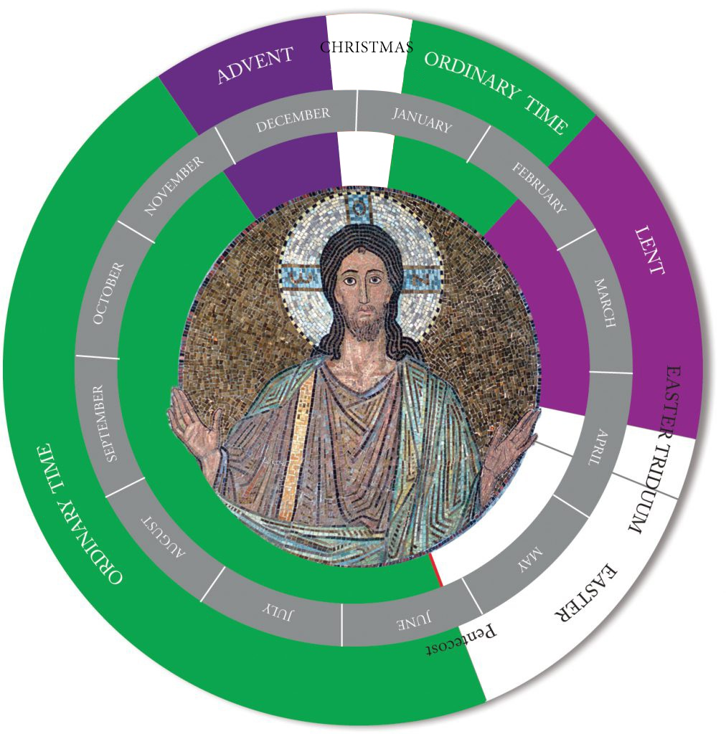

The Books of the Old Testament
THE PENTATEUCH | BIBLICAL NOVELLAS | PROPHETIC BOOKS
Genesis | Tobit | Isaiah
Exodus | Judith | Jeremiah
Leviticus | Esther | Lamentations
Numbers | 1 Maccabees | Baruch
Deuteronomy | 2 Maccabees | Ezekiel
HISTORICAL | WISDOM BOOKS | Daniel
INTRODUCTION | Job | Hosea
Joshua | Psalms | Joel
Judges | Proverbs | Amos
Ruth | Ecclesiastes | Obadiah
1 Samuel | Song of Solomon | Jonah
2 Samuel | Wisdom | Micah
1 Kings | Sirach | Nahum
2 Kings |  | Habakkuk
1 Chronicles |  | Zephaniah
2 Chronicles |  | Haggai
Ezra |  | Zechariah
Nehemiah |  | Malachi

The Books of the New Testament

THE GOSPELS | LETTERS | CATHOLIC LETTERS
Matthew | Romans | James
Mark | 1 Corinthians | 1 Peter
Luke | 2 Corinthians | 2 Peter
John | Galatians | 1 John
Acts of the Apostles | Ephesians | 2 John
 | Philippians | 3 John
 | Colossians | Jude
 | 1 Thessalonians | Revelation
 | 2 Thessalonians
 | 1 Timothy
 | 2 Timothy
 | Titus
 | Philemon
 | Hebrews

Source: USCCB website 7/2025

