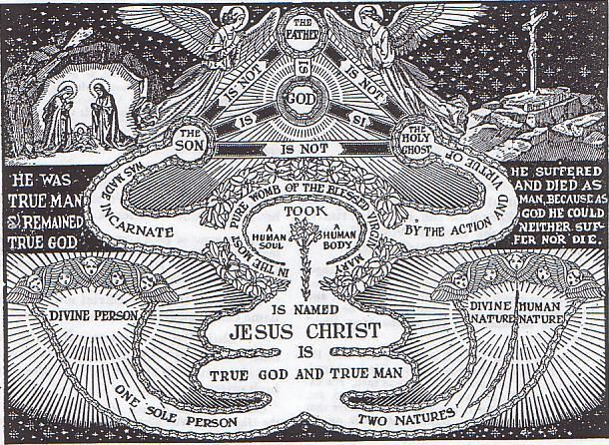
JESUS CHRIST, THE SON OF GOD…THE INCARNATION

“I am trying here to prevent anyone saying the really foolish thing that people often say about Him [that is, Christ]: ‘I’m ready to accept Jesus as a great moral teacher, but I don’t accept His claim to be God.’ That is the one thing we must not say. A man who was merely a man and said the sort of things Jesus said would not be a great moral teacher. He would either be a lunatic–on a level with the man who says he is a poached egg–or else he would be the Devil of Hell. You must make your choice. Either this man was, and is, the Son of God: or else a madman or something worse…. You can shut Him up for a fool, you can spit at Him and kill Him as a demon; or you can fall at His feet and call Him Lord and God. But let us not come up with any patronising nonsense about His being a great human teacher. He has not left that open to us. He did not intend to.”

–C.S. Lewis in Mere Christianity

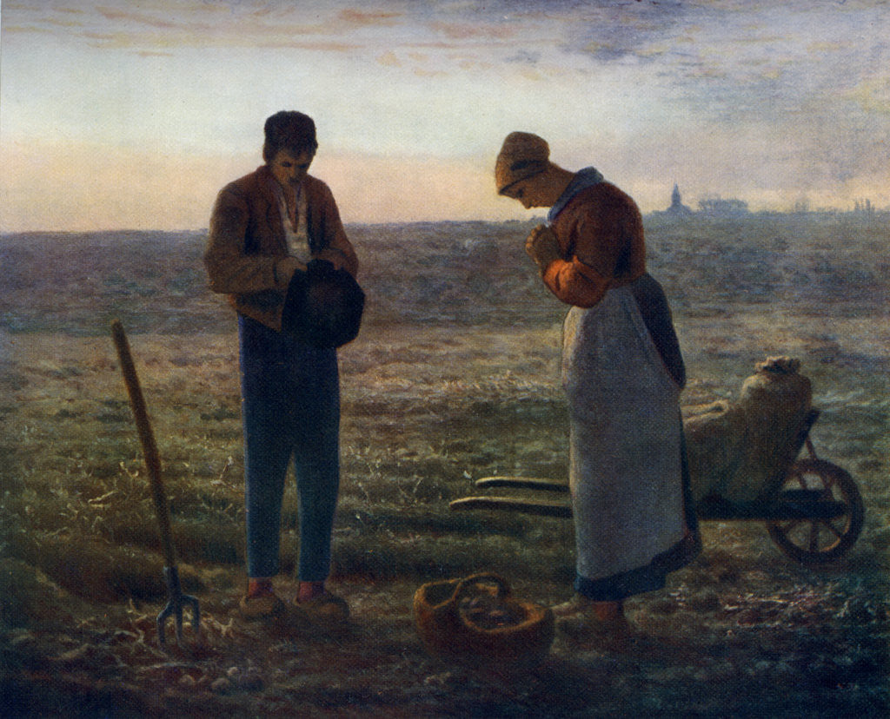

The Angelus 1857-1859
Jean François Millet

Millet said: "The idea for The Angelus came to me because I remembered that my grandmother, hearing the church bell ringing while we were working in the fields, always made us stop work to say the Angelus prayer for the poor departed."

