Welcome to the 16th Annual Saint Raymond of Peñafort Summer Reading Program
Seven Weeks of Summer Reading Fun from June 22nd – August 10th 2026!
Here’s what you do…Read, Review, Return!
Rising K* - Rising 5th Graders: Read 7 grade level books about the treasures of the catholic Faith – Our Lord, Our Lady, Our Heroes, Our Traditions, Our History, Our Teachings. * Yes, pre-readers can be read to!
Rising 6th – Rising 8th Graders: Read 3 such grade level books as described above.
Return the completed form by August 10th to the Parish Office or to the Parish Library during Open Hours to be eligible for a prize!
A trove of truly terrific books for all ages is available in the Parish Library.
Library Open Hours: Every Saturday 1:00 – 5:00pm and Sunday 10:00am – 2:00pm, by appointment or request it be opened by a parish staff member during regular office business hours. The Library will be closed on Saturday, the 4th of July.
Please note that the library is volunteer staffed so posted open hours are subject to volunteer availability.
Name: __________________________________________ email: _______________________ Grade Level: _______

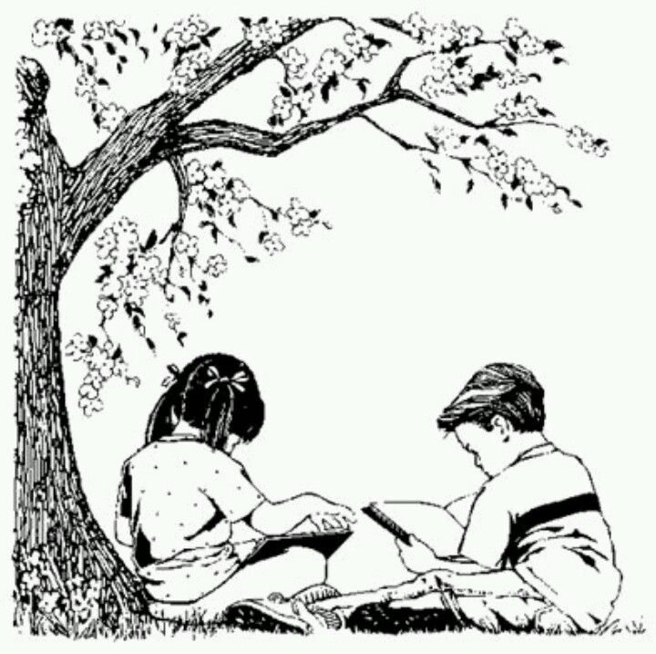
“You will not find anyone who is truly striving after his
spiritual advancement
who is not given to spiritual reading.”

Saint Athanasius
Patron Saint of our Parish Library

- Title: _________________________________________________________ Author: _____________________________
Lesson Learned: _________________________________________________________________________________________

- Title: _________________________________________________________ Author: _____________________________
Lesson Learned: _________________________________________________________________________________________

- Title: __________________________________________________________Author: ____________________________
Lesson Learned: _________________________________________________________________________________________

- Title: _________________________________________________________ Author: _____________________________
Lesson Learned: _________________________________________________________________________________________

- Title: _________________________________________________________ Author: ____________________________
Lesson Learned: _________________________________________________________________________________________

- Title: _________________________________________________________ Author: _____________________________
Lesson Learned: _________________________________________________________________________________________

- Title: __________________________________________________________Author:____________________________
Lesson Learned: _________________________________________________________________________________________

